reg no: 192111496

Name: M KRISHNA VAMSHIDHAR REDDY

**CODE: CSA1366**

**EXPERIMENT: 7**

**AIM:** To design Turing machine to perform addition of following

W= aa + aaaa

After addition of a’s=aaaaaa

**PROCEDURE:**

1. Select SIX states and consider one as initial and another as final state.
2. Join the states using edges with directioons
3. Select the edges as INPUT and OUTPUT as a or b or c.
4. Give the input and start the simulation.

**DESIGN AND OUTPUT:**

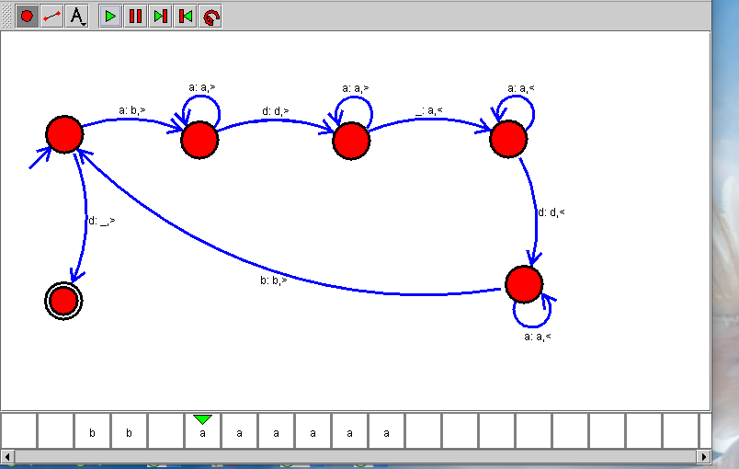

**RESULT:**

Therefore the designing of turing machine for the given input has been successfully created and stimulated.